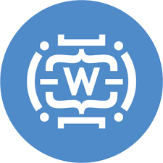

**BIOGRAPHY**

An authentic description about who you are besides your work hisotry and education. You can share personal treats and strengts. Demonstrate capabilities with personal examples.

**PERSONAL DETAILS**

Share your personal details, contact details and possibly a hyperlink to your LinkedIn profile and portfolio.

**TECHNICAL SKILLS**

Summarize your technical skills, suchs as CRM systems, programming languages and management tools.

**INTERESTS**

Share your interests. Make it personal by sharing fun details and examples.

**YOUR NAME**YOUR CATCHY & DESCRIPTIVE HEADLINE

**WORK HISTORY**

Period // Organization // Location  
Job Title

Here you describe your main responsibilities, followed by an enumeration of key tasks.

**EDUCATION**

Period // Education Institution // Location  
Course Title

Describe your key lessons learned and possible awards/achievements.

**CERTIFICATES**

**VOLUNTARY WORK**